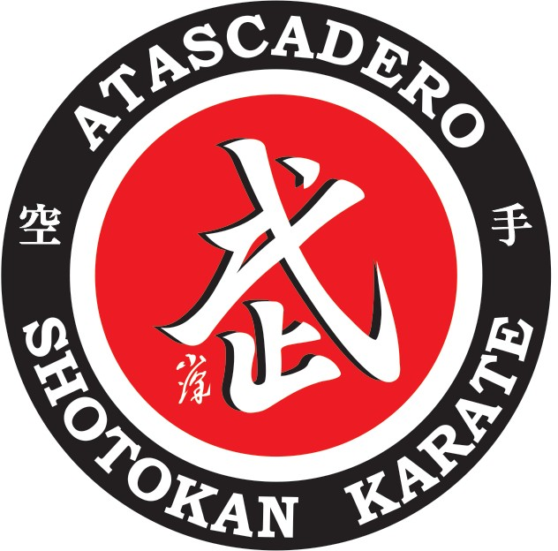

Assumption of the Risk and Waiver of Liability Relating to COVID-19

The novel coronavirus, COVID-19, has been declared a worldwide pandemic by the World Health Organization. COVID-19 is extremely contagious and is believed to spread mainly from person-to-person contact. As a result, federal, state, and local governments and federal and state health agencies recommend social distancing and have, in many locations, prohibited the congregation of groups of people.
However, Atascadero Shotokan Karate (“the dojo”) has been certified to reopen under San Luis Obispo County guidelines and has put in place preventative measures to reduce the spread of COVID-19. The dojo cannot guarantee that you will not become infected with COVID-19. Further, attending the dojo could increase your risk of contracting COVID-19.

**************************************************************************
By signing this agreement, I acknowledge the contagious nature of COVID-19 and voluntarily assume the risk that I may be exposed to or infected by COVID-19 by attending the dojo and that such exposure or infection may result in personal injury, illness, permanent disability, and death. I understand that the risk of becoming exposed to or infected by COVID-19 at the dojo may result from the actions, omissions, or negligence of myself and others, including, but not limited to, the dojo owner, volunteers, other students and their families.
I voluntarily agree to assume all of the foregoing risks and accept sole responsibility for any injury to myself (including, but not limited to, personal injury, disability, and death), illness, damage, loss, claim, liability, or expense, of any kind, that I may experience or incur in connection with my attendance at the dojo. On my behalf, I hereby release, covenant not to sue, discharge, and hold harmless the dojo, its owner, agents, and representatives, of and from the claims, including all liabilities, claims, actions, damages, costs or expenses of any kind arising out of or relating thereto. I understand and agree that this release includes any claims based on the actions, omissions, or negligence of the dojo, its owner, agents, and representatives, whether a COVID-19 infection occurs before, during, or after participation in any class.

Signature of Student if 18 years or older  or Parent/Guardian | Date
Print Name of Student if 18 years or older | Name of minor Student(s)
or Parent/Guardian

